## **GnP: in relation to Accessibility, Inclusion and Learning Pathways**

## **Commitment**

## As stated in its Equity, Diversity and Inclusion policy, groove’n’play is committed to providing accessible learning materials and features on its e-learning platforms, groove@school and groove@home.

## GnP strives to create an inclusive learning environment where individuals feel valued, respected, and heard, regardless of their background or identity.

## groove’n’play works and will continue to work, to improve its e-learning platforms to try to accommodate the individual needs of all children and young people, to enhance their learning experience in a way that is appropriate to them.

## **Accessible Resources and Learning Styles**

GnP provides Accessible Easy Read information for groove’n’play ethos and pedagogy, as it relates to the context of the wider educational sector, including the National Curriculum for Music, and National Plan for Music.  
  
The groove’n’play sessions are designed with multiple access points to provide meaningful engagement for all.

The groove’n’play programmes use a variety of audio and visual media resources within groove@school and groove@home. These provide options for teachers and students alike, to choose the best access route for them.

In its session plans, groove’n’play encourages varied teaching and learning styles suited to teacher and student alike. These include visual (spatial), aural (auditory), verbal (linguistic), physical (kinesthetic), logical (mathematical), social (interpersonal) and solitary (intrapersonal) learning styles.

The following example is taken from ukuleles sticks and songs, to give a snapshot of a GnP groove@home programme:

  
**for children to feel at home wherever they are,**

**accessible and easy-to-use.**

* makes learning music fun
* can be used in any way appropriate for an individual   
  to learn and experience music
* offers choice of stylistically varied songs that support learning
* provides enjoyable musical experiences

**example: ukuleles sticks & songs**

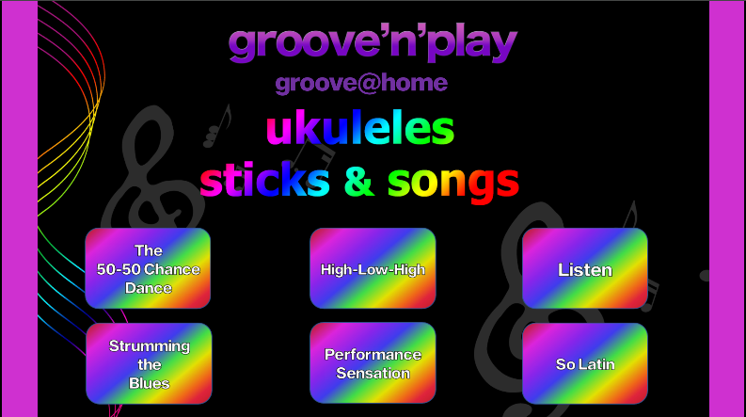 **simple and easy-to-use navigation**



sections can be repeated many times



animated visuals highlight the lyrics



colourful actions and movements give visual clues

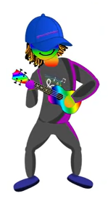

*Groovester* gives visual tips on how and when to play

## **example: animated learning tools**

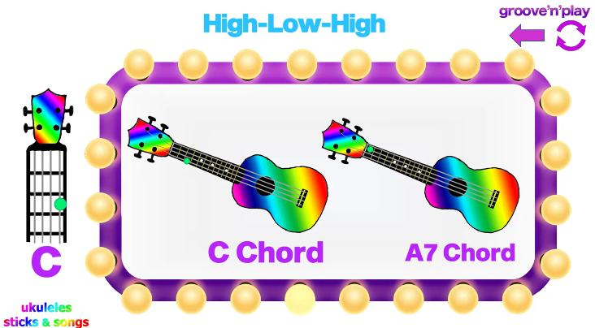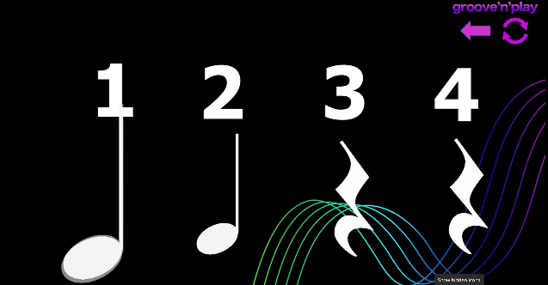 **Animated beat work**

## **The songs in a nutshell:**

**The 50-50 Chance Dance:**

feel good action song – move, clap, tap along

(think you’re at a barn dance)

**High-Low-High:**

Atmospheric and relaxing suitable for swaying, rocking, smooth floating movements,

(think waving your scarf on a beach).

**Listen:**

Slow and reflective bringing the senses alive – gives time and space to listen,

(don’t think, just listen to the world around you).

**Strumming The Blues:**

Powerful beat-based groove along,

(think an air guitar moment on a big stage).

**A Performance Sensation:**

Uplifting and energising – get ready to perform,

(think celebration and your big moment).

**So Latin:**

Dance and movement inspiring Latin classic feel,

(think letting it go on the dance floor).

## **Adaptive instruments and technology**

GnP encourages the use of adaptive instruments and technology to support meaningful engagement:  
  
GnP suggests using tools or instruments suited, and where necessary modified, to meet an individual’s needs, to give the best opportunity for engagement for each young person, as a valued member of the GnP performance team.  
  
For example, use of one-handed recorders, adaptive tables and desks, adapted playing techniques, use of technology-based instrumental sounds.

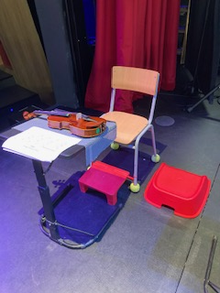GnP received comments from a school to say what adaptations that they had introduced, which they felt were appropriate to give the required access for one of their pupils.

These simple adaptations which included: an instrument table or stand, foot stool, non-slip mat, stickered violin, and low seat for support teacher, aided the pupil to be able to engage meaningfully in the GnP Strings Programme. After one year of engagement in the programme, the pupil was one of 75 performers, in an end of year concert.

GnP also recommends to teachers and tutors, the Guide to Buying Adaptive Musical Instruments, which was created in response to research undertaken by the Take it away Consortium (a partnership between Creative United, Drake Music, Music for Youth, The OHMI Trust, Open Up Music and Youth Music). The guide is downloadable from the [Take it Away website](https://takeitaway.org.uk/news/adaptive-musical-instrument-guide/)

## **Choice and Relevance:**

Teachers and children are encouraged, when using groove@school and groove@home, to select the learning path best suited to them.

Some teachers and students may prefer to access the programmes using the groovester buttons, which give a more animated, visually guided learning pathway, to achieve specific goals.

A student may also decide to concentrate on one particular instrumental aspect of a particular piece, for example percussion (sticks and shaky eggs). There will be visual and aural resource support, as well as activities, to aid them in achieving their identified goal.

Although in the programmes, there is guidance about instrument hold and rest position, the actual hold and rest position must be suited to the physical abilities of each young person.

GnP programmes, whilst not stated as specifically written solely for children with additional abilities, they are resources that are intended to support music making for all. Teachers and pupils are encouraged to access and use the programmes in the ways best suited to each individual, to effect meaningful music and learning experiences.

GnP programmes reflect a diverse range of music genres, but GnP also encourages exploration of genres and artists beyond those represented in the bespoke compositions of the programmes, so as to expand each individual’s own knowledge and music interests.

For more information please go to our websites:

[www.groovenplay.com](http://www.groovenplay.com)

[www.grooveatschool.com](http://www.grooveatschool.com)

If you would like to contact us, please do get in touch and email:

info@groovenplay.com